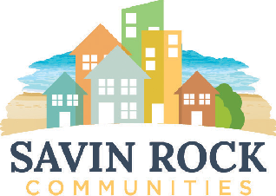
BOARD OF COMMISSIONERS
Wayne A. Orio, Chairman
John R. O’Connor, Vice-Chairman Harold Burns, Treasurer
Richard Tracy
Jasmin Nugent
John P. Counter
Executive Director
For landlords & renters:

Savin Rock Communities has partnered with AffordableHousing.com, which provides an enhanced program to list rental properties online. Listings are available to potential Housing Choice Voucher tenants seeking units in the private market. Affordable Housing toll free helpline at 1-866-466-7328
For property owners looking to add your rental property, click the link below. We recommend that you add photos to your listing for better advertising and faster lease up.
Landlords add your rental property https://www.affordablehousing.com/
For tenants looking to find Housing Choice Voucher (Section 8) listings, click the link below.
Tenants search portal view rental listings https://www.affordablehousing.com/
Legal Disclaimer: Savin Rock Communities does not perform a verification process on the landlords listed on Affordable Housing website. By offering a link to Affordable Housing on this site, Savin Rock Communities makes no representation, express or implied, as to the truth, accuracy, validity of any landlord or listing. To Avoid scams by doing your research! https://consumer.ftc.gov/articles/rental-listing-scams#report Know your rights! Go to https://ctlawhelp.org/en/tenants-renters-rights-laws for details
Other resources:
- AFFORDABLEHOUSING.COM
- ZILLOW.COM
- APARTMENTS.COM
- CRAIGSLIST.COM
- REALTOR.COM
- NEWHAVENREGISTER.COM
- RENT.COM
- FORRENT.COM
- HOTPADS.COM
- REALTORS
Security Deposit Assistance (based on funding availability)
- Liberty Community Services: 203-495-7600 or visit https://www.libertycs.org/
- Community Action: 203-387-7700 or visit https://www.caanh.net/contact-us/
- United Way of CT / Effective Community Services: Call 211 or visit https://www.211ct.org/
- State of CT DOH, 2nd floor, 505 Hudson Street, Hartford, CT 06106 https://portal.ct.gov/DOH/DOH/Programs/Security-Deposit-Program
- Teaminc.org 203 736 5420 or info2@teaminc.org https://teaminc.org/housing-assistance/

