

Section 8 Offices

23B Glade Street, West Haven, CT 06516

Tel: (203) 934-9266 Fax: (203) 937-0306

[**www.savinrockcommunities.org**](http://www.savinrockcommunities.org)

|  |  |  |  |  |
| --- | --- | --- | --- | --- |
| **West Haven Apartments**  **(The list is updated around the 1st & 15th of each month)** | | | | |
| **LL FIRST NAME** | **LL LAST NAME** | **UNIT / APT ADDRESS** | **PHONE #** | **OTHER PHONE** |
| **One Bedroom** | | | | |
|  |  |  |  |  |
| Sandro | Colonna | 148-156 Elm Street 1st flr | 203-996-5028 |  |
| Jose | Echavarria | 164 Park St lower level | 203-382-3863 | Avail 10/1 |
| Kenneth Garden |  | 33 Kenneth Street | 475-267-1820 |  |
| **Two Bedrooms** | | | | |
| Sandro | Colonna | 148-156 Elm Street 1st flr. | 203-996-5028 |  |
| Daniel | Skibitcky | 88 Dana Street 2nd flr | 203-606-2693 |  |
| Brian | Breeding | 215 Jaffrey St Unit C | 203-376-4296 |  |
| Michael | Quoka | 89 Coleman Road #623 | 203-500-3653 |  |
| Dana | Marra | 23 May Street 2nd flr. | 908-419-5511 |  |
| Gisela | Vidal | 76 Greta St Apt E4 | 203-300-7467 | Avail July 1st |
| Yuwell | Mitchell | 64 Lamson Street 1st flr | 203-466-9004 | Avail. July 1, 2025 |
| John | Jaser | 80 Claudia Drive Unit 160 | 203-605-5755 |  |
| Jeanne | Albano | 140 Capt. Thomas Blvd # 509 | 203-731-7548 |  |
| Julie | Stancarone | 397 Meadowbrook Court | 203-931-7278 | Waitlist |
| **Three Bedrooms** | | | | |
| **LL FIRST NAME** | **LL LAST NAME** | **UNIT / APT ADDRESS** | **PHONE #** | **OTHER PHONE** |
| Mike | Mercuriano | 280-282 Elm Street 2nd flr | 203-934-7938 |  |
| Keila | Vargas | 65 Fourth Ave 1st flr | 631-637-0141 |  |
| Lesly | Guity | 102 Hinman Street 1st flr. | 203-668-7364 |  |
| Jeiver | Espinosa | 386 Platt Ave #1 | 1-917-523-6321 |  |
| Harriet | Snipe | 57 Dalton Street 1st and 2nd flr | 203-821-1804 | 804-499-8194 |
| **Four Bedrooms**   |  |  |  |  |  | | --- | --- | --- | --- | --- | | **LL FIRST NAME** | **LL LAST NAME** | **UNIT / APT ADDRESS** | **PHONE #** | **OTHER PHONE** | | Keila | Vargas | 203 Main street 2nd flr. | 631-637 |  | | Tania | Melo | 9 Gilbert Street 2nd and 3rd flr | 203-500-5544 |  | | Brian | Banning | 872 Campbell Ave 2nd flr | 203-668-6144 |  | | | | | |

**FIVE BEDROOMS**

|  |  |  |  |  |  |
| --- | --- | --- | --- | --- | --- |
| **LL FIRST NAME** | **LL LAST NAME** | **UNIT / APT ADDRESS** | | **PHONE #** | **OTHER PHONE** |
| Gary | Barnett | 40 Orlando Str 2nd and 3rd flr | 203-600-0419 | |  |
|  |  |  |  | |  |

Other landlords for possible vacancies (please note they may not have vacancies at the time of this published list)

|  |  |
| --- | --- |
| ABCD Investments DE LLC | (203) 773-9710 |
| Campbell Realty Group LLC | 203-751-9712 |
| Campbell Street Associates,LLC | 860-997-7835 |
| Coleman Court Associates | 203-937-6933 |
| CPI Group/CT Suites | 860-468-9759 |
| Crestview House | (203) 333-2266 |
| DJ Realty LLC | 203-907-3203 |
| Elizabeth Lake View LLC | (203) 891-5832 |
| Elm Court Associates LLC | 914-668-0195 |
| Elm Regency Limited Partnership | 203-932-3138 |
| Grove Hill Assoc. LLC | 203-931-7700 |
| LJS Realty LLC | 203-497-8888 |
| Orange Gardens LLC | (203) 204-2420 |
| Park Garden Apts LLC | 203-381-1327 |
| Spring Realty | 203-937-1700 |
| Terrace Park Apts LLC | 203-732-2916 |

**UPDATED 09/09/2025**

**RESOURCES FOR SEARCHING:**

* AFFORDABLEHOUSING.COM
* ZILLOW.COM
* APARTMENTS.COM
* CRAIGSLIST.COM
* REALTOR.COM
* NEWHAVENREGISTER.COM
* [RENT.COM](http://www.rent.com/connecticut/west-haven-houses)
* [FORRENT.COM](https://www.forrent.com/find/CT/metro-Central+CT/West+Haven)
* HOTPADS.COM
* REALTORS

**Security Deposit Assistance** (based on funding availability)

* Liberty Community Services: 203-495-7600 or visit <https://www.libertycs.org/>
* Community Action: 203-387-7700 or visit <https://www.caanh.net/contact-us/>
* United Way of CT / Effective Community Services: Call 211 or visit <https://www.211ct.org/>
* State of CT DOH, 2nd floor, 505 Hudson Street, Hartford, CT 06106 <https://portal.ct.gov/DOH/DOH/Programs/Security-Deposit-Program>

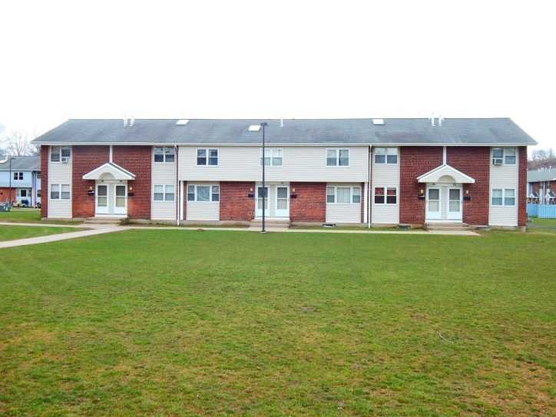Meadow Landing Apartments

397 Meadowbrook Court

West Haven, CT 06516

**2 bedrooms - $1567.00**

**3 bedrooms- $1811.00**

Currently accepting applications for 2 & 3 bedrooms!

Meadow Landings Apartments are situated off exit 42 I-95. **Across from Shoprite on Bull Hill Lane.** We are located near shopping, restaurants, major highways, and the bus line. Our apartments have hardwood floors throughout! We offer fully appliance kitchens which include a refrigerator, dishwasher, stove/hood. We have onsite laundry, assigned parking and onsite management.

First month’s rent and one month’s security deposit due upon move in. No application fee required. **Must meet our income guidelines.**

**Please call for additional information 203-931-7278.**

**2 habitaciones - $ 1567.00  
3 habitaciones- $ 1811.00**  
Actualmente aceptamos solicitudes para 2 y 3 dormitorios.  
  
Meadow Landing Apartments está situado junto a la salida 42 I-95. **Situado frente a Shoprite en Bull Hill Lane.** Estamos ubicados cerca de tiendas, restaurantes, autopistas principales y la línea de autobuses. Nuestros apartamentos tienen pisos de madera noble en todas partes. Ofrecemos cocinas totalmente equipadas que incluyen refrigerador, lavaplatos, estufa / campana. Tenemos lavandería en el lugar, estacionamiento asignado y administración en el lugar.  
  
El primer mes de alquiler y el depósito de seguridad de un mes vencen al momento de la mudanza. No se requiere tarifa de solicitud.

**Debe cumplir con nuestras pautas de ingresos.**  
Por favor llame para obtener información adicional 203-931-7278.