Section 8 Offices 23B Glade Street, West Haven, CT 06516
Tel: (203) 934-9266 Fax: (203) 937-0306
West Haven Apartments
List also available on www.savinrockcommunities.org
(The list is updated the 1st & 15th of each month)

LL FIRST NAME | LL LAST NAME |  | UNIT / APT ADDRESS | PHONE # | OTHER PHONE
One Bedroom
Brick Properties | Brian Breeding | 149 Canton Street #10 |  | 203-376-4296
Orange Gardens |  |  | 131 Dogburn Rd | 475-271-1551
Kenneth Gardens |  |  | 33 Kenneth St | 475-267-1820
Two Bedrooms
Sandro | Colonna |  | 152 Elm Street unit 9 | 203-996-5028
Jessica | Hall |  | 94 Hinman Street | 203-626-1555
Joe | D’Aurio |  | Mallard Brook Crossing | 203-627-9061
Julie | Stancarone |  | 397 Meadowbrook Court | 203-931-7278 | Waitlist
Three Bedrooms
LL FIRST NAME | LL LAST NAME |  | UNIT / APT ADDRESS | PHONE # | OTHER PHONE
Kari | Flash |  | 11 Myrtle Ave 2nd flr | 860-603-3834
Harriet | Snipe |  | 57 Dalton Street 1st and 2^{nd flr} | 804-499-8194 | Available ASAP
Four Bedrooms

UPDATED 07/09/2024

Other landlords for possible vacancies (please note they may not have vacancies at the time of this published list)
ABCD Investments DE LLC | (203) 773-9710
Barreta Management DBA Glenstone Mgmt LLC | 203-200-0233
Campbell Realty Group LLC | 203-751-9712
Campbell Street Associates,LLC | 860-997-7835
Coleman Court Associates | 203-937-6933
CPI Group/CT Suites | 860-468-9759
Crestview House | (203) 333-2266
DJ Realty LLC | 203-907-3203
Elizabeth Lake View LLC | (203) 891-5832
Elm Court Associates LLC | 914-668-0195
Elm Regency Limited Partnership | 203-932-3138
Golden Management LLC | (917) 645-7199
Grove Hill Assoc. LLC | 203-931-7700
Hillcrest Properties LLC | 203-675-3666
K Treat Street LLC | (203) 659-0300
LJS Realty LLC | 203-497-8888
Orange Gardens LLC | (203) 204-2420
Park Garden Apts LLC | 203-381-1327
Rolling Ridge CT, LLC | 203-416-6809
Spring Realty | 203-937-1700
Terrace Park Apts LLC | 203-732-2916
Vesta Properties, LLC | 203 687-6669

RESOURCES FOR SEARCHING:
- AFFORDABLEHOUSING.COM
- ZILLOW.COM
- APARTMENTS.COM
- CRAIGSLIST.COM
- REALTOR.COM
- NEWHAVENREGISTER.COM
- RENT.COM
- FORRENT.COM
- HOTPADS.COM
- REALTORS
Security Deposit Assistance (based on funding availability)
- Liberty Community Services: 203-495-7600 https://www.libertycs.org/
- United Way of CT / Effective Community Services: https://www.211ct.org/
- State of CT DOH, 2nd floor, 505 Hudson Street, Hartford, CT 06106 https://portal.ct.gov/DOH/DOH/Programs/Security-Deposit-Program

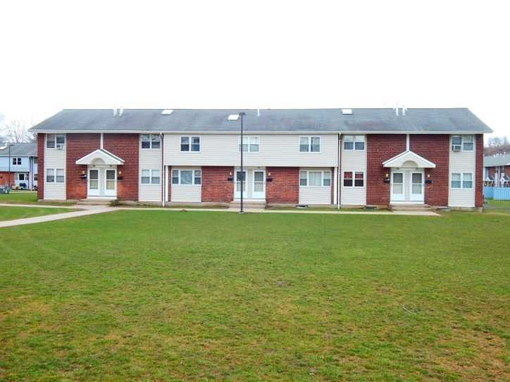
Meadow Landing Apartments

397 Meadowbrook Court

West Haven, CT 06516

2 bedrooms - $1549.00
3 bedrooms- $1789.00
Currently accepting applications for 2 & 3 bedrooms!

Meadow Landings Apartments are situated off exit 42 I-95. Across from Shoprite on Bull Hill Lane. We are located near shopping, restaurants, major highways, and the bus line. Our apartments have hardwood floors throughout! We offer fully appliance kitchens which include a refrigerator, dishwasher, stove/hood. We have onsite laundry, assigned parking and onsite management.

First month’s rent and one month’s security deposit due upon move in. No application fee required. Must meet our income guidelines.
Please call for additional information 203-931-7278.

2 habitaciones - $ 1549.00
3 habitaciones- $ 1789.00
Actualmente aceptamos solicitudes para 2 y 3 dormitorios.
Meadow Landing Apartments está situado junto a la salida 42 I-95. Situado frente a Shoprite en Bull Hill Lane. Estamos ubicados cerca de tiendas, restaurantes, autopistas principales y la línea de autobuses. Nuestros apartamentos tienen pisos de madera noble en todas partes. Ofrecemos cocinas totalmente equipadas que incluyen refrigerador, lavaplatos, estufa / campana. Tenemos lavandería en el lugar, estacionamiento asignado y administración en el lugar.
El primer mes de alquiler y el depósito de seguridad de un mes vencen al momento de la mudanza. No se requiere tarifa de solicitud.
Debe cumplir con nuestras pautas de ingresos.
Por favor llame para obtener información adicional 203-931-7278.

