Section 8 Offices 23B Glade Street, West Haven, CT 06516
Tel: (203) 934-9266 Fax: (203) 937-0306

West Haven Apartments
List also available on www.savinrockcommunities.org
(The list is updated the 1st & 15th of each month)

LL FIRST NAME |  | LL LAST NAME | UNIT / APT ADDRESS | PHONE # |  | OTHER PHONE
One Bedroom
Sandro |  |  | 154 Elm St #12 (2nd FL) | 203-996-5028
Orange Gardens |  |  | 131 Dogburn Rd | 475-271-1551 |  | diosy@npointmanagement.com
Kenneth Gardens |  |  | 33 Kenneth St | 475-267-1820
Two Bedrooms
BFB Properties |  | Brian Banning | 211-213 Spring Street 1st 2nd and 3rd flr | 203-668-6144
Franker |  | Aguaze | 113 Admiral Street 3rd flr | 475-434-3323
Claudio |  | Arduni | 746 Campbell ave | 203-675-6409
Claudia |  | Arduini | 748 Campbell Ave 2nd Flr | 203-675-6409
Joe |  | D’Aurio | Mallard Brook Crossing | 203-627-9061
Christine  Moises |  | Andrews  Delgado | 50 Thomas Street 2nd flr | 203-313-2613 or  845-309-5401
Brian |  | Breeding | 89 Coleman St. Unit 400 (Brick Properties) | 203-376-4296
Julie |  | Stancarone | 397 Meadowbrook Court | 203-931-7278
Three Bedrooms
Drew |  | Mistry | 69 Church St | 203-933-7513 |  | Available ASAP
Harriet |  | Snipe | 57 Dalton Street 2nd | 804-499-8194 |  | Available ASAP
Four Bedrooms
Five Bedrooms
Leo | Shis | 43 Jones st. 2nd flr | 203-802-5513

UPDATED 03/26/2024

***OUT OF TOWN APARTMENTS***

One Bedroom
Two Bedrooms
Three Bedrooms
MLC  Properties | 293 Division St  New Haven, CT | 203-467-7068

Four Bedroom
Galo Narvaez | 24 Cassius Street New Haven, CT 06519 | 301-409-9323

Other landlords for possible vacancies (please note they may not have vacancies at the time of this published list)
ABCD Investments DE LLC | (203) 773-9710
Barclay Enterprises LLC | 777-4599
Barreta Management DBA Glenstone Mgmt LLC | 203-200-0233
Campbell Realty Group LLC | 203-751-9712
Campbell Street Associates,LLC | 860-997-7835
Coleman Court Associates | 203-937-6933
CPI Group/CT Suites | 860-468-9759
Crestview House | (203) 333-2266
DJ Realty LLC | 203-907-3203
Elizabeth Lake View LLC | (203) 891-5832
Elm Court Associates LLC | 914-668-0195
Elm Regency Limited Partnership | 203-932-3138
Forest Enterprises, LLC | 777-4599
Golden Management LLC | (917) 645-7199
Grove Hill Assoc. LLC | 931-7700
Had Jac Enterprises LLC | 777-4599
Hillcrest Properties LLC | 203-675-3666
K 414 East 120th St Associates LP | 203-659-0300 x1
K Treat Street LLC | (203) 659-0300
K414East 120th Street Assoc. LP | (203) 659-0300
Kenneth Gardens Associates, LLC | 914-668-0195
Kimberly Gardens Assoc. | 931-7700
Kings NH, LLC | (203) 891-5832
LJS Realty LLC | 497-8888
Orange Gardens LLC | (203) 204-2420
Park Garden Apts LLC | 203-381-1327
Rolling Ridge CT, LLC | 203-416-6809
Spring Properties | 937-1700
Spring Realty | 203-937-1700
Terrace Park Apts LLC | 203-732-2916
Vesta Properties, LLC | 203 687-6669

RESOURCES FOR SEARCHING:
- GOSECTION8.COM
- Afffordablehousing.com
- ZILLOW.COM
- APARTMENTS.COM
- CRAIGSLIST.COM
- REALTOR.COM
- NEWHAVENREGISTER.COM
- doorsteps.com
- rent.com
- forrent.com
- hotpads.com
- Realtors

Security Deposit Assistance (based on funding availability)
- Liberty Community Services 203-495-7600 https://www.libertycs.org/
- United Way of CT / Effective Community Services
https://www.211ct.org/
- State of CT DOH, 2nd floor, 505 Hudson Street, Hartford, CT 06106
https://portal.ct.gov/DOH/DOH/Programs/Security-Deposit-Program

Meadow Landing Apartments

397 Meadowbrook Court

West Haven, CT 06516
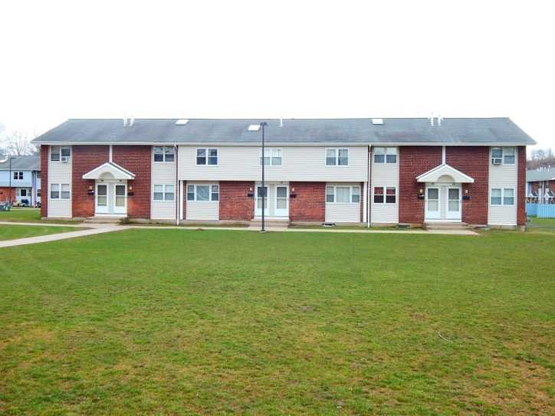
2 bedrooms - $1549.00
3 bedrooms- $1789.00

Currently accepting applications for 2 & 3 bedrooms!

Meadow Landings Apartments are situated off exit 42 I-95. We are located near shopping, restaurants, major highways, and the bus line. Our apartments have hardwood floors throughout! We offer fully appliance kitchens which include a refrigerator, dishwasher, stove/hood. We have onsite laundry, assigned parking and onsite management.

First month’s rent and one month’s security deposit due upon move in. No application fee required. Must meet our income guidelines.
Please call for additional information 203-931-7278.

Across from Shoprite on Bull Hill Lane

Meadow Landing Apartments

397 Meadowbrook Court

West Haven, CT 06516
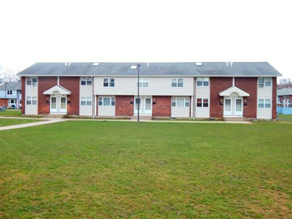

2 habitaciones - $ 1549.00
3 habitaciones- $ 1789.00
Actualmente aceptamos solicitudes para 2 y 3 dormitorios.
Meadow Landing Apartments está situado junto a la salida 42 I-95. Estamos ubicados cerca de tiendas, restaurantes, autopistas principales y la línea de autobuses. Nuestros apartamentos tienen pisos de madera noble en todas partes. Ofrecemos cocinas totalmente equipadas que incluyen refrigerador, lavaplatos, estufa / campana. Tenemos lavandería en el lugar, estacionamiento asignado y administración en el lugar.
El primer mes de alquiler y el depósito de seguridad de un mes vencen al momento de la mudanza. No se requiere tarifa de solicitud.
Debe cumplir con nuestras pautas de ingresos.
Por favor llame para obtener información adicional 203-931-7278.
Situado frente a Shoprite en Bull Hill Lane

